Sheet 4

- find the Fourier transforms of the signals shown in Figure below:

- find the inverse Fourier transforms of the spectra shown in Figure below:

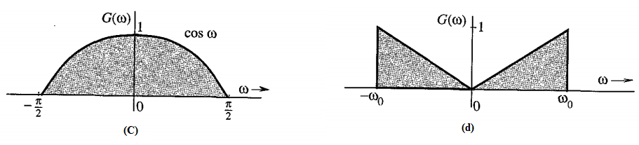
- Drive the Fourier transform of :
$$f\left(t\right)=A[u\left(t+3T\right)-u\left(t+T\right)+u\left(t-T\right)-u\left(t-3T\right)]$$

- Drive the Fourier transform of :
$$f\left(t\right)=\frac{A}{T}t[u_{o}\left(t+T\right)-u_{o}\left(t-T\right)]$$

- The signals in Figure are modulated signals with carrier$cos⁡(10t)$. Find the Fourier transforms of these signals using the appropriate properties of the Fourier .Sketch the amplitude and phase spectra for parts (a) and (b). Hint: These functions can be expressed in the form$g\left(t\right)cos (ω_{o}t)$.

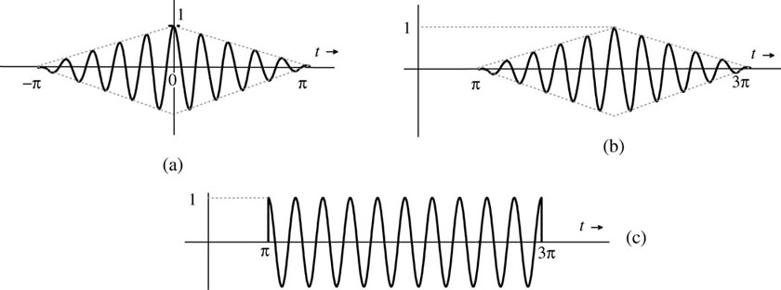

- Drive the Fourier transform of the waveform in the figure:

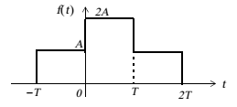
- Using the differentiation property of Fourier transform find the frequency spectrum of :
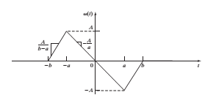

Good Luck

